**Power BI (**<https://powerbi.microsoft.com/en-us/downloads/>**)**

Power BI Link

|  |  |
| --- | --- |
| <https://www.linkedin.com/learning/search?keywords=Power%20BI%20Essential%20Training> | Power BI Essential Training Learning LinkedIn and certification |
| <https://powerbi.microsoft.com/en-us/get-started/> | Downloading power bi desktop |
| <https://powerbi.microsoft.com/en-us/report-server/> | Downloading Microsoft Power BI Report Server  <https://docs.microsoft.com/en-us/power-bi/report-server/install-report-server> |
| <https://www.microsoft.com/en-us/sql-server/sql-server-downloads> | SQL Server 2019 |

Desktop installation

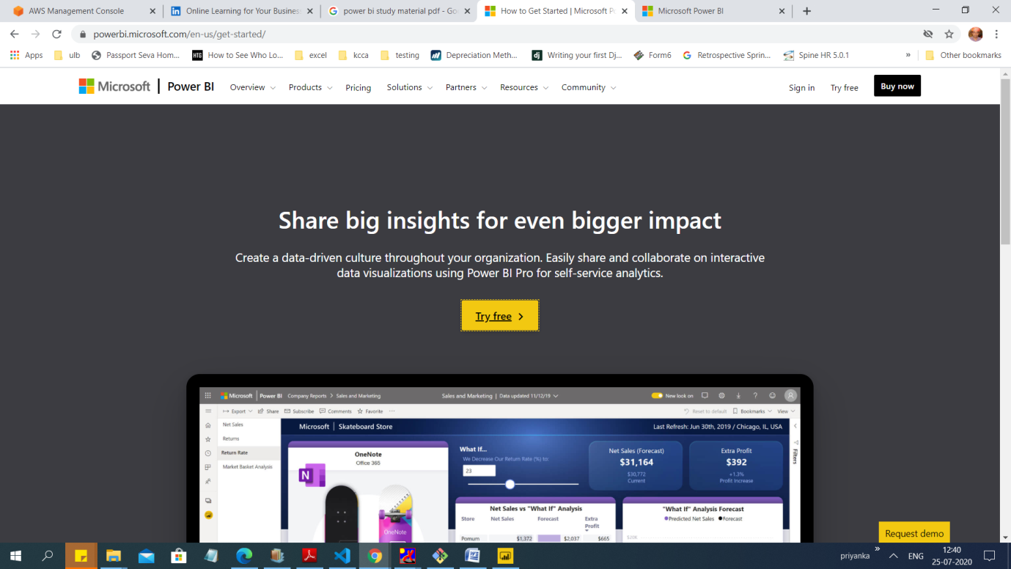

Before installation required company mail id

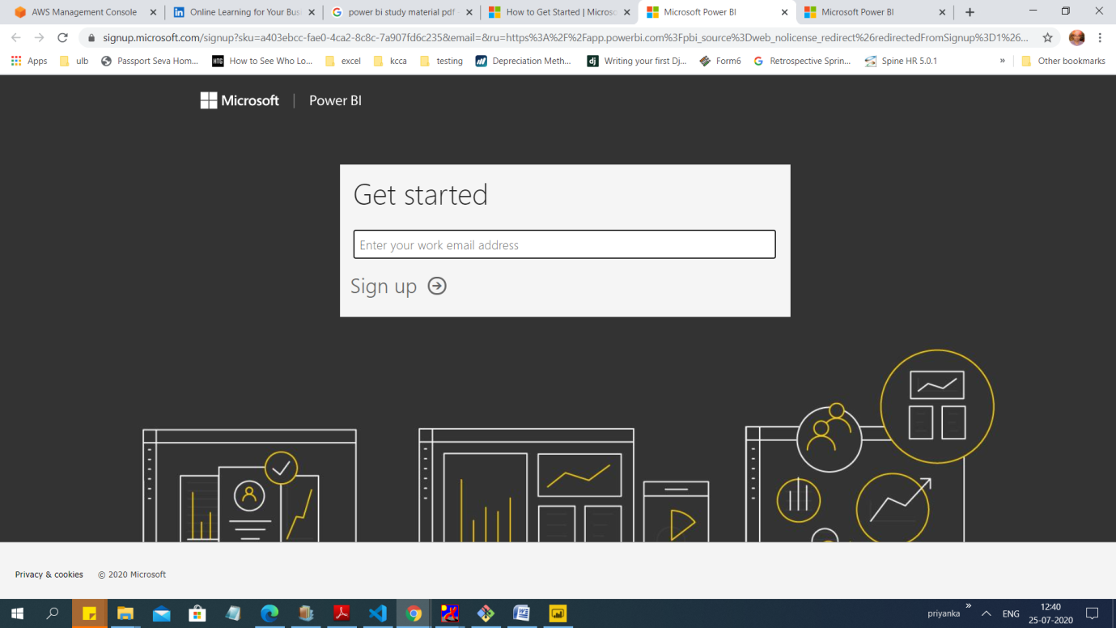

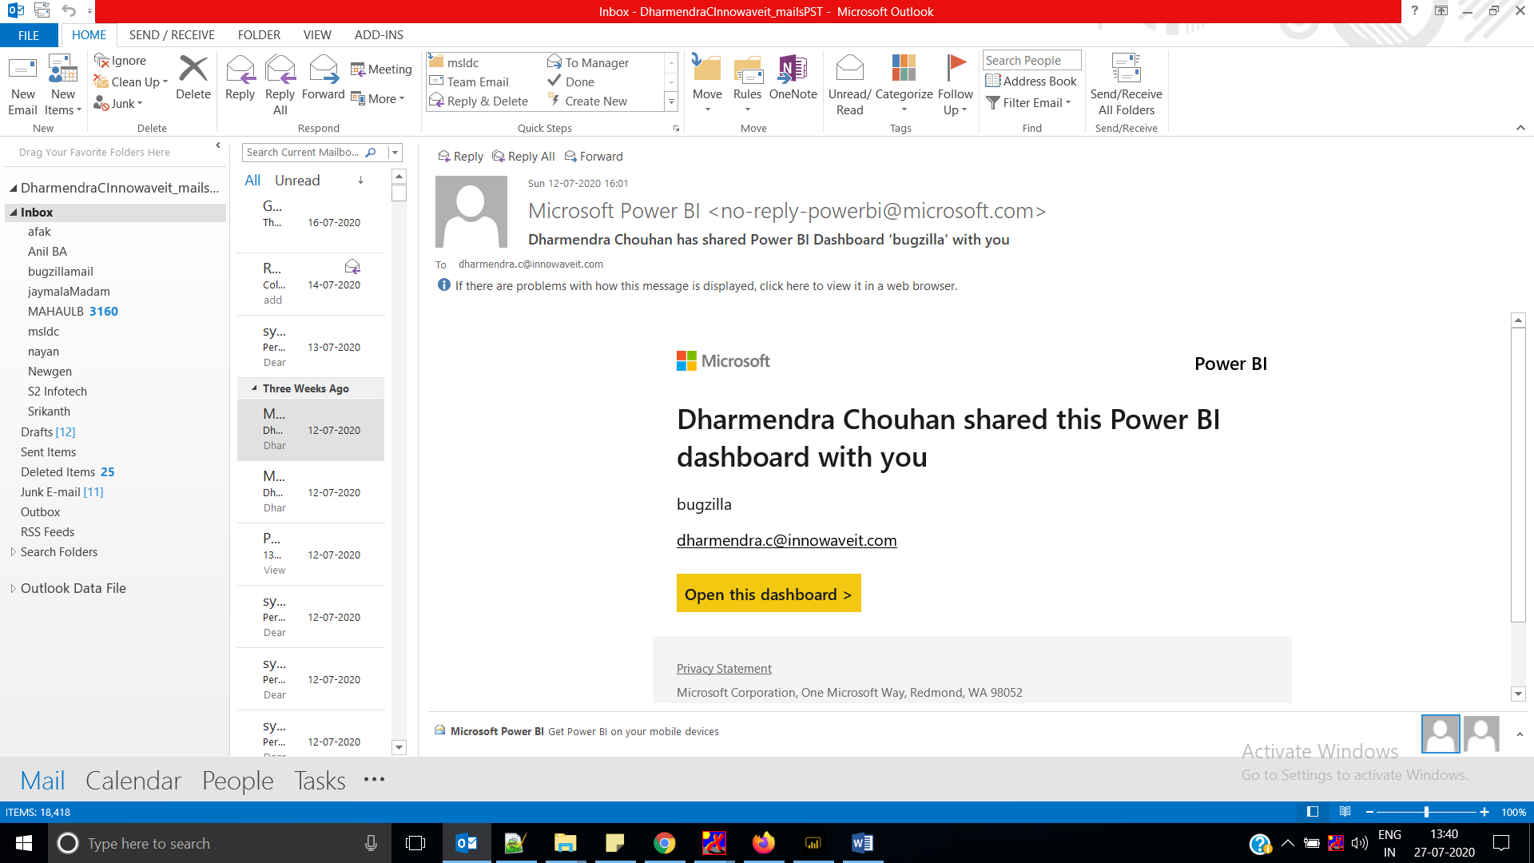

After installation open Power bi desktop

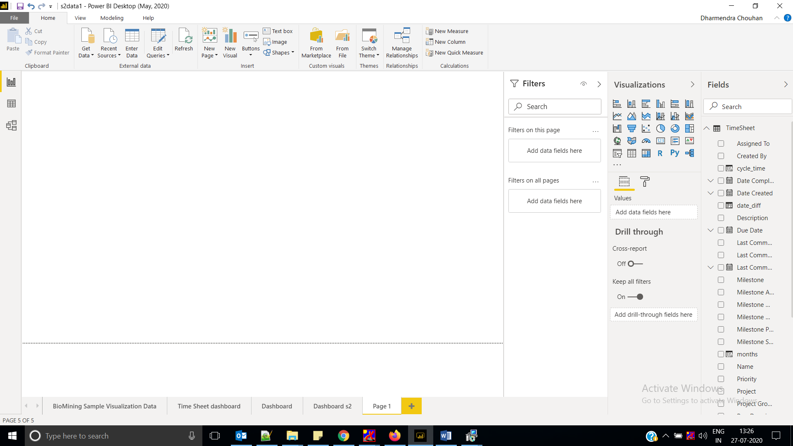

Reporting Server

(<https://docs.microsoft.com/en-us/power-bi/report-server/install-report-server>)

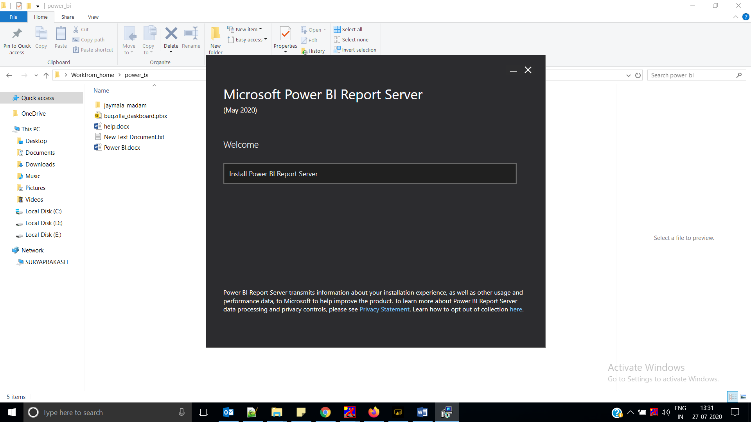

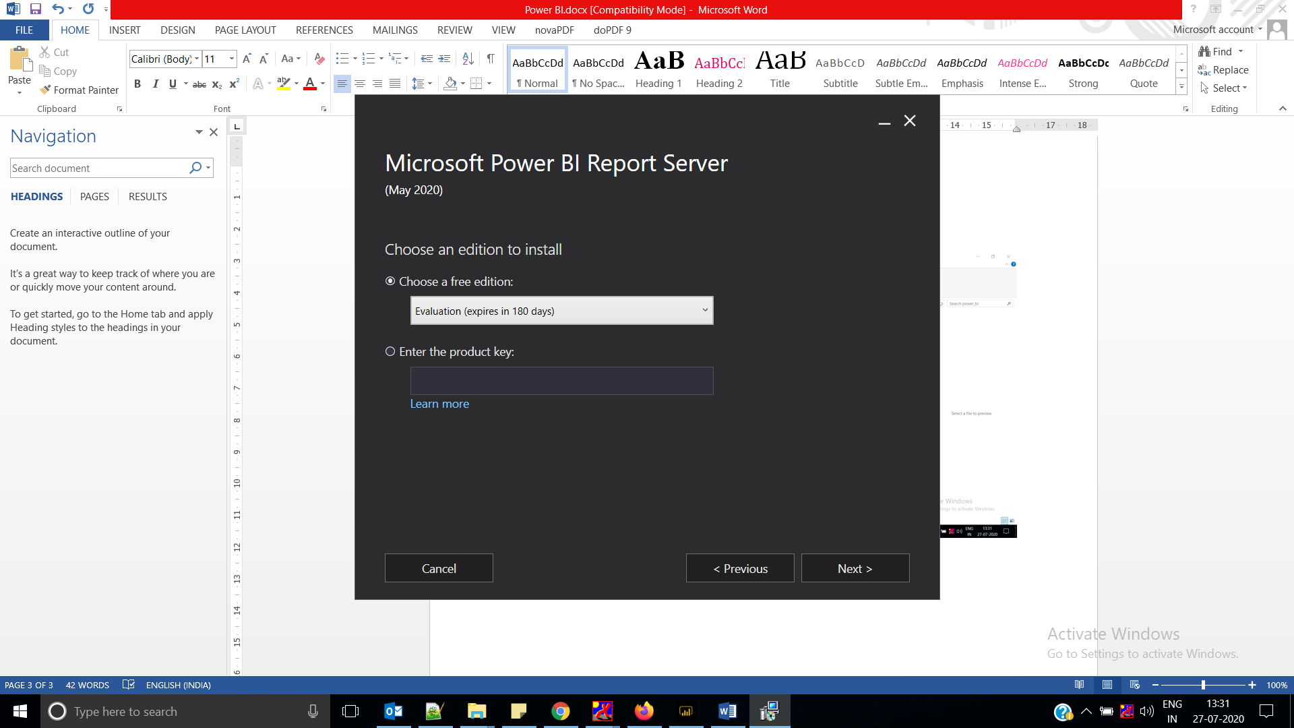

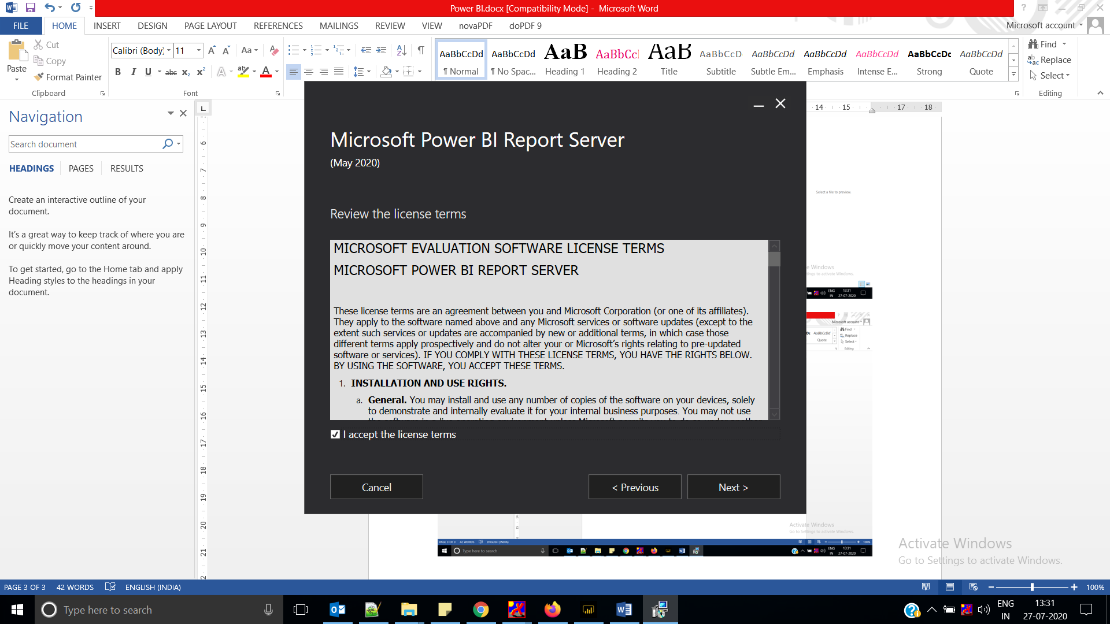

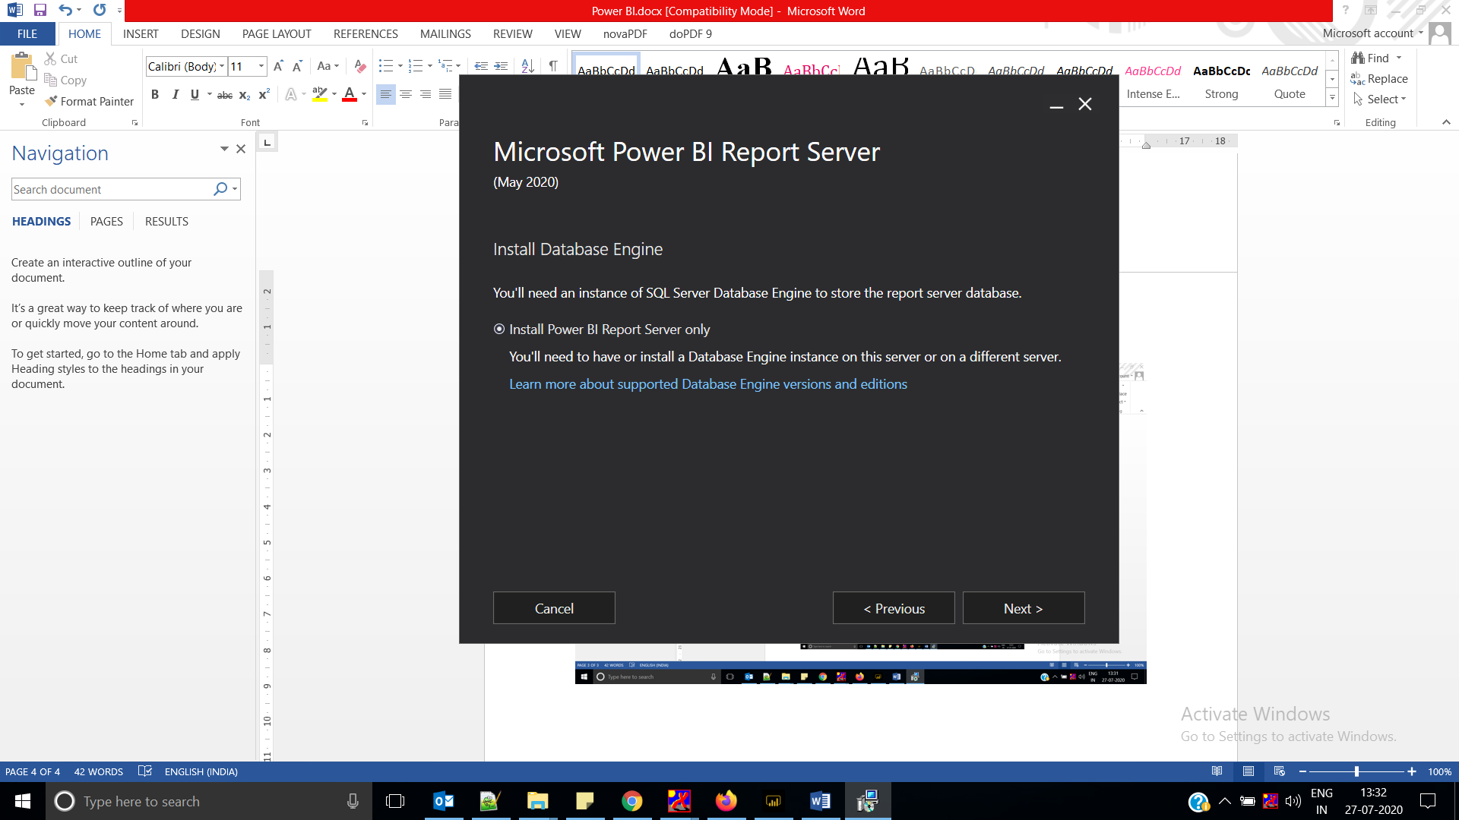

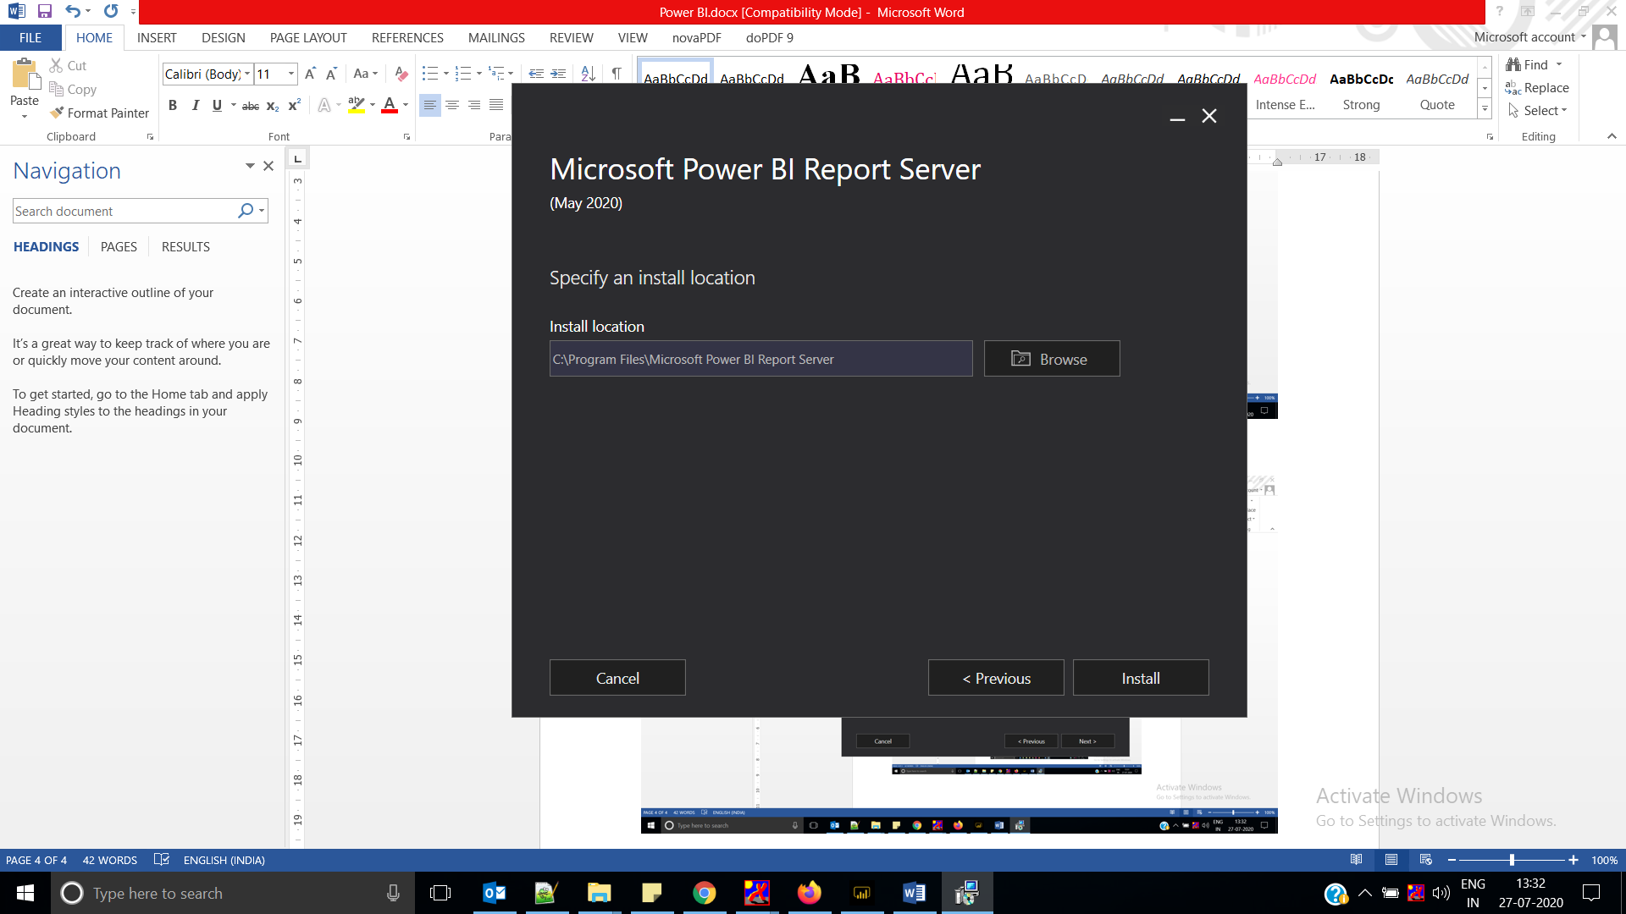

SQL Server 2019

Download and install SQL Server 2019 free trial

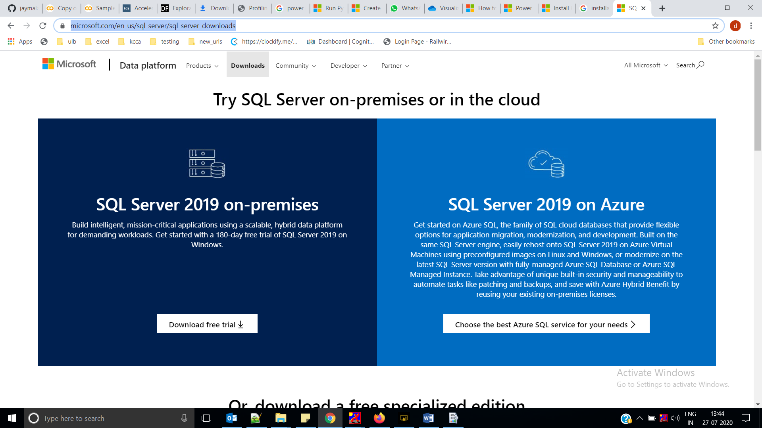

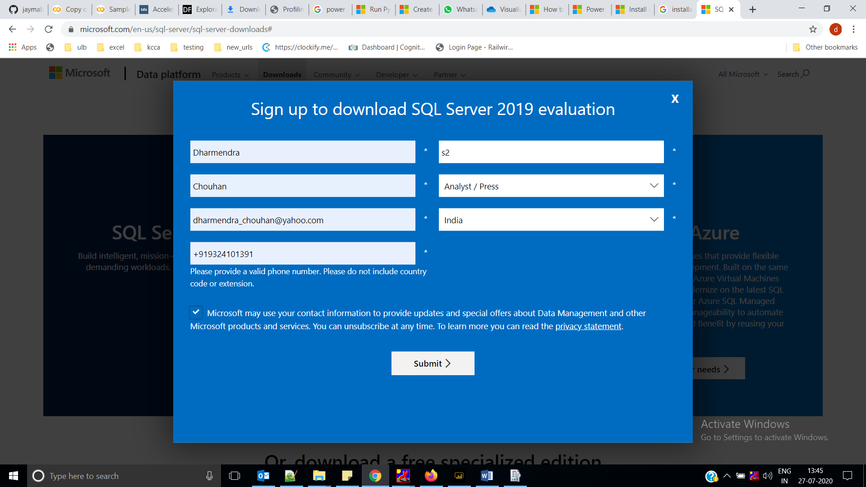

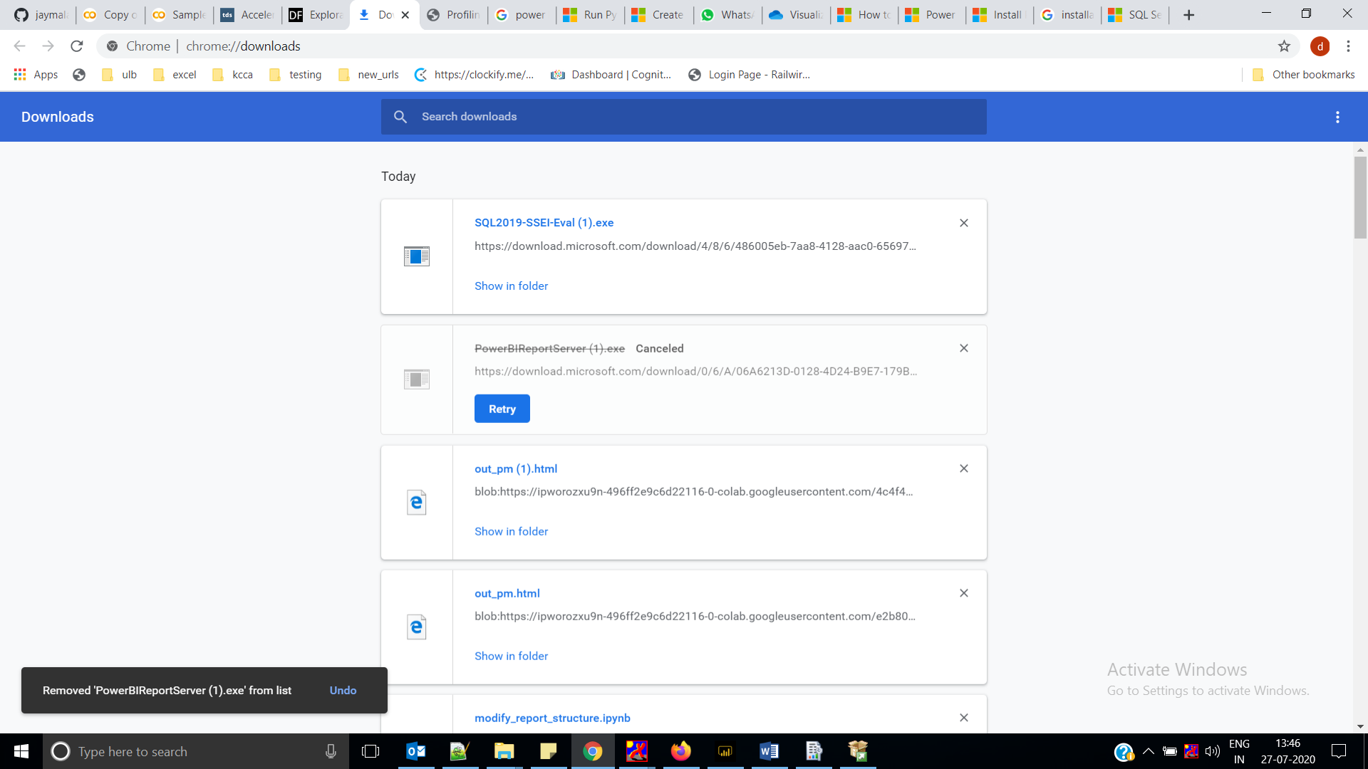

Click on “SQL2019-SSEI-Eval (1).exe” and install SQL server

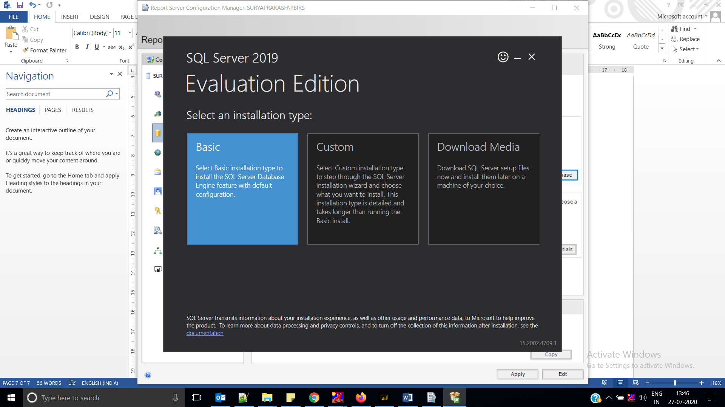

Run Report Server Configuration Manager

